NEPAL COLLEGE OF INFORMATION TECHNOLOGY

Affiliated to Pokhara University
CASE STUDY ON
Smart ATM Security System
Using IoT and Face Recognition
Course Name: Internet of Things
Course Code: CMP370
Program: B.E. Information Technology
Semester: Sixth Semester
Submitted By: Suraj Kumar Jha
Roll Number: 231537
Submitted To: Er. Rishi K. Marseni
Date: 11 July 2026
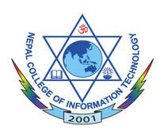
Department of Information Technology
NEPAL COLLEGE OF
INFORMATION TECHNOLOGY
Balkumari, Lalitpur, Nepal

